**To make conversational blocks....in two sequences:**

**1.Convert your .its files to .cha files**

**2. Make blocks to be labelled**

From Lena software program...  
First you have to get the .its files converted to .cha(t) files (the files are called chat files but their file extension is .cha (because file extensions are only three letters, I.e. .pdf); alternatively, the second file type required to make blocks which are .wav files, dont need to be converted.   
Therefore, .its need to be converted to .cha;  
and .wav files for each converted .cha file need to be stored in the same place where the .cha files are exported to, after the file conversion.   
  
**Steps to convert .its to .cha**  
1. Access files from the Lena desktop application.   
  
2. When relevant (participant files for block-making) raw files are found via file directory within Lena, files need to be exported for file conversion before blocks can be made. To export, first find export button in bottom left of screen.  
Clicking that button will open a window with many options for export. The defaults will set a reporting on 5-minute time frames. The only options that need to be selected are as follows:   
A) Set date of file to be exported (typically, 1 file of each kind for export at a time); &  
B) Select .cha to be exported (.wav file is exported automatically).   
Both will be exported to desktop.  
  
3. Click export/ok. - .its files in addition to .wav files from Lena will be exported to desktop folder for quick retrieval for file conversion.

4. Create a new folder and put them in a folder on desktop.  
  
5. When .its are successfully exported (very quick), and the file directory specified (new desktop folder), then use the desktop application called Clan to convert .its to .cha. (for the process in Soderstrom lab, these files need to be accessed on S:/ on 'Laverne' computer which is our only computer that has Clan program installed).   
  
6. When Clan has been opened, the lena2cha command is run in Clan over an .its file. In the command box, type:   
**lena2chat** (add a space, add **file name** and then add the **.its** file you exported from Lena, which you will find in the directory you created in new desktop folder). Remember to add the .its file extension before you continue.  
  
The command box text you enter before you hit run, should look something like this.

Figure 1 - lena2chat function in CLAN

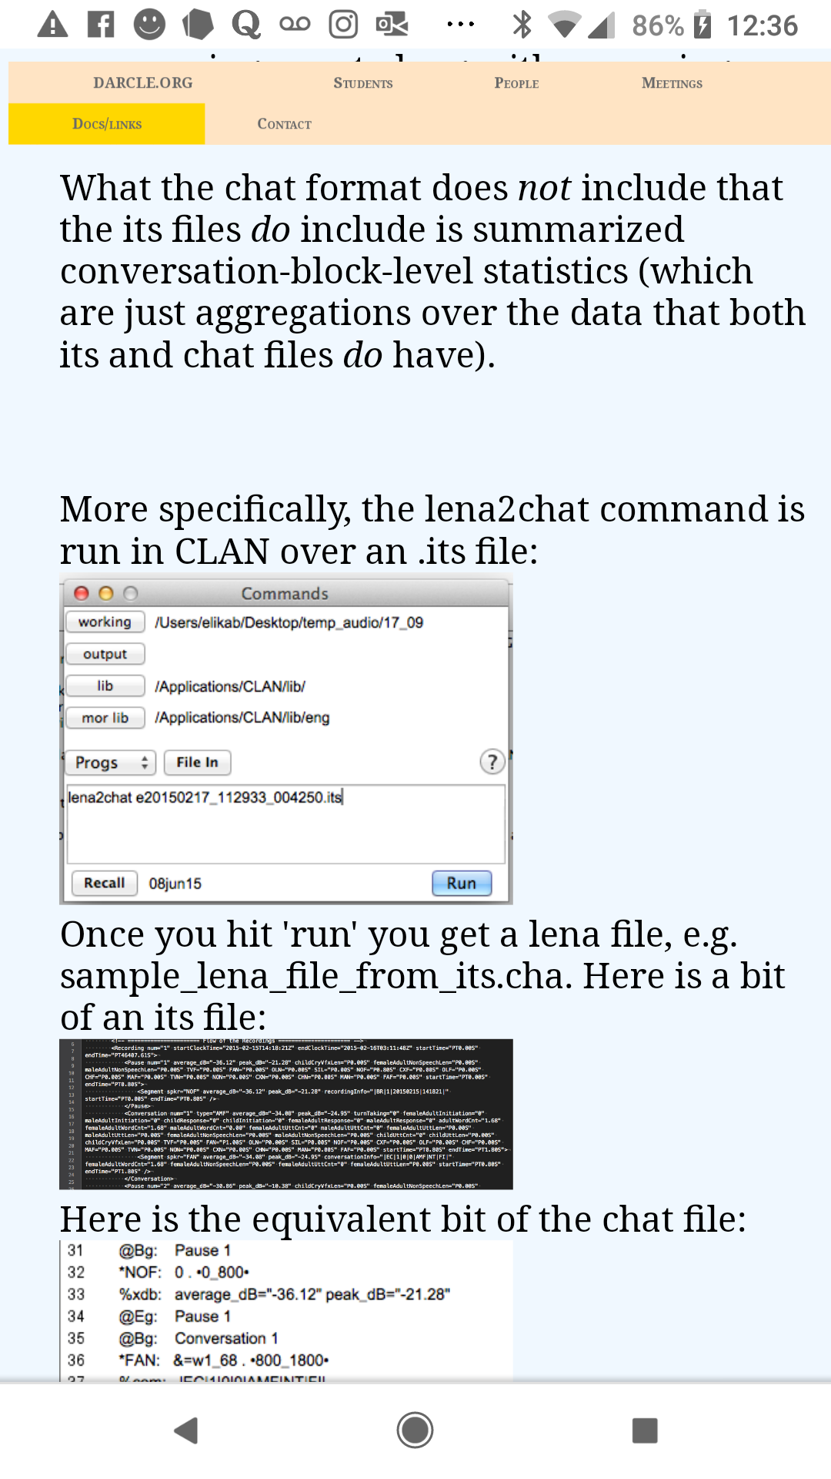  
**Before** you click run, click the **working** **button** (see picture) to establish where the .its file is taken from for the file conversion (this is the new folder you created when you exported .its file from Lena.  
  
**Before** you click run, also click **output** **button** to establish the destination for your new .cha file. (You will need to create a new folder location where your .cha(t) files will go, if you haven't already 😊.   
  
**Note**: you can move the corresponding .wav files in this next folder too, because you will need .wav and .cha files in the same place before you make blocks, and remember.wav files don’t need to be converted, so they are good to go!   
  
7. Then click **Run**   
  
  
Now you should have your newly created .cha file and your corresponding .wav file. (**This process has to be done for each participant recording that you need to make blocks for**).  
**Make sure they both have the same filename**. **The only thing different will be the file extension (the last three letters) for each file (.wav and .cha).**   
  
**Making blocks:**  
1. Make sure you now have a file folder with both .cha and .wav files: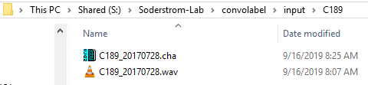

There should be three folders: One folder in the file directory labeled input (I.e. input for making blocks); inside the input folder, include another folder with the folder name = participant number; thirdly, then a general folder that you put those files in input folder into, after blocks are made. That way, the input folder remains empty for next batch of .its and .wav files for making blocks.   
  
2. Go to Convolabel  
  
3. Click upper left drop down menu from the title bar:

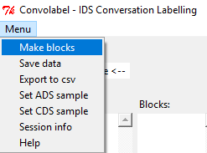  
  
4. From drop down menu, click make blocks (blocks can only be made from south east computer in P504a).   
  
5. When program is finished running, you can see your blocks in convolabel.